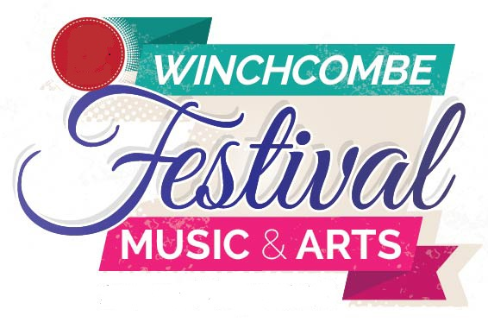

STREET FAIR
MONDAY 27TH MAY 2019
A very popular event in this lovely Cotswold Town.
North Street closed to traffic
Stalls and entertainment
Book a stall now!
Cost: £40 per stall (or £35 per stall if booking and payment received before end of December 2018) Booking form overleaf.
Contact name
Business name
Address
Email
Telephone
Nature of items sold (for information purposes only)
Date

Please note, all stallholders must have their own Public Liability Insurance cover.
To secure your stall booking please:
- Pay direct to the Festival bank account – account number 40484468, sort code 30-91-87 and email completed booking form to stalls.wfma@gmail.com OR send completed booking form and cheque payable to Winchcombe Festival of Music and Arts to Lynne Banks, St Marys, Cowl Lane, Winchcombe, Glos. GL54 5RA

- Send a copy of your Public Liability Insurance cover via email or post to the addresses above

